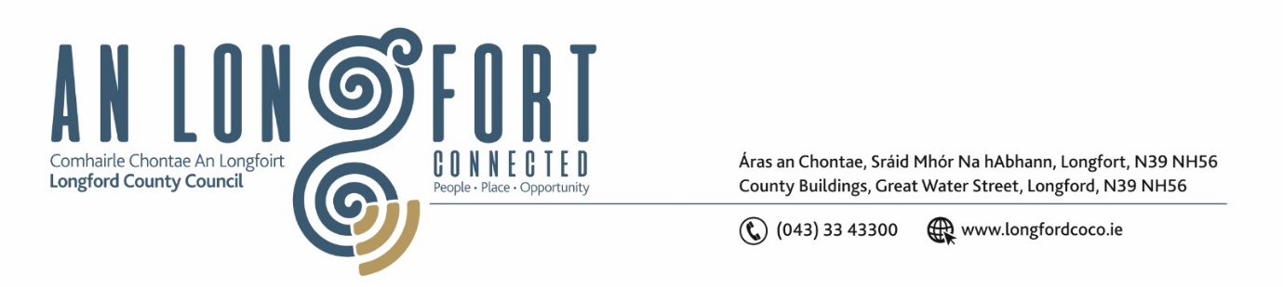

**LONGFORD MUNICIPAL DISTRICT**

**Minutes of Meeting of Longford Municipal District held via MS Teams and in the Goldsmith Suite, Aras an Chontae,**

**on Wednesday, 23 March 2022 at 10.15am**

**CATHAOIRLEACH**: Councillor Uruemu Adejinmi

**MEMBERS PRESENT**: Councillors – Seamus Butler, Martin Monaghan,

John Browne, Peggy Nolan, Gerry Warnock.

**IN ATTENDANCE**: Mr. John Brannigan, Director of Services.

.

Ms. Lorraine Mc Kee, Administrative Officer.

**MEETINGS**

**ADMINISTRATOR:**  Ms. Ann Marie Mc Keon

**APOLOGIES:** Councillor Gerry Hagan.

Mr. Eamonn Bennett, Senior Executive Engineer

**ADOPTION OF MINUTES – circulated**

On the proposal of Councillor Gerry Warnock seconded by Councillor John Browne, it was unanimously agreed to adopt Minutes of Committee Meeting of Longford Municipal District held on the 23 February 2022.

On the proposal of Councillor John Browne seconded by Councillor Seamus Butler, it was unanimously agreed to adopt Minutes of Committee Meeting of Longford Municipal District held on the 23 February 2022.

**MATTERS ARISING FROM MINUTES**

None.

**DECLARATION OF INTEREST BY MEMBERS**

None.

**MANAGEMENT REPORT INCORPORATING AREA ENGINEER’S PROGRESS REPORT – circulated**

Noted.

Major Well’s Road

Councillor Seamus Butler requested an update on when works would be completed at Major Well’s road. Executive Engineer, Brian Faughnan informed the members that the road design section anticipate that the works will be completed by the end of 2022. The elected members expressed their disappointment at this news and requested that a member from road design attend the next meeting to provide a programme of works and explain the delay.

The elected members sought a date for the commencement of the Market Square works and Director of Services John Brannigan informed the members that clarification has been sought from the contractor in relation to the increased costs in construction and the contractor is to provide an update by Friday 25 March on whether or not they can complete the project at the price they submitted.

Street Cleaning

Councillor Gerry Warnock asked if the street cleaning roster could be re-instated to pre-COVID-19 and Brian confirmed that it could.

Trees at Shannonvale

The members requested that a letter be sent to the residents at Shannonvale on the reports received on the condition of the trees at this location.

**PROPOSED PROJECTS/EXPRESSION OF INTERESTS**

None.

**CONSIDERATION OF SCHEDULE OF LONGFORD MUNICIPAL DISTRICT WORKS – as circulated**

On the proposal of Councillor Seamus Butler seconded by Councillor John Browne, it was unanimously agreed to adopt the Schedule of Longford Municipal District Works, as circulated.

**Best Wishes**

The members wished Director of Services, John Mc Keon a speedy recovery.

This concluded the business of the meeting.

Ann Marie Mc Keon

**Signed: ____________________**

**Ann Marie Mc Keon**

**Meetings Administrator.**

**Confirmed and adopted at Longford Municipal District Meeting held on the 27 April 2022.**

Uruemu Adejinmi

**Signed: _______________**

**Cathaoirleach.**